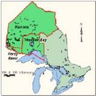

Products and Industries Picture Map

Each student will create a map based on their state. Each map must be 8”x 11”. You can get the paper from your teacher. Maps must be in full color, well organized, and neatly completed. The map must contain the following elements to be considered completed:

The Map:
- Draw an outline of your state.
- Label the capital and three major cities
- Label the location of where five products are produced
- Label the location of where five industries are located
- Draw an example of each product and industry

